**TABLE OF CONTENT**

# Team 5: Networked Appetite

## Team Members: Anamika kafle, Aakriti Neupane, Gaurab Rana, Bishwas Ghimire, Mansi Deep

**1. Initiation Phase**

1.1. Project Charter

* Version Control --------------------------------------- 4
* Project Justification ---------------------------------- 4
* Project Scope ------------------------------------------ 5
* Project Assumption ----------------------------------- 7
* Rules and Responsibilities -------------------------- 8

1.2. Meeting Minutes --------------------------------------- 10

**2. Planning Phase**

2.1. Belbin Analysis

* Team Belbin Analysis --------------------------- 15
* Individual Belbin Analysis ----------------------- 22

2.2. Skills Audit

* Individual Skill Audit ------------------------------- 24
* Team Skill Audit -------------------------------------- 25

2.3. Project Management (MS Project)

* Calendar ------------------------------------------- 26
* Network Diagram ---------------------------------- 27
* Timeline ---------------------------------------------- 29
* WBS --------------------------------------------------- 29
* Change Working Time ----------------------------- 30
* Resource Sheet -------------------------------------- 30
* Gantt Chart ------------------------------------------- 31

2.4. Communication Tool Used

* Slack ------------------------------------------------------ 31

**3. Execution**

3.1. Entity Relationship Diagram

* EERD -----------------------------------------------------34
* ERD -----------------------------------------------------36
* Final Composite ---------------------------------------37
* Logical Table -------------------------------------------38

3.2. Use Case Diagram

* Overview Use Case Diagram -----------------------39
* Customer Use Case Diagram -----------------------40
* Trader Use Case Diagram ---------------------------41
* Admin Use Case Diagram ---------------------------42

3.3. Requirement Catalogue

* Functional Requirement ----------------------------43
* Non-Functional Requirement ---------------------49

3.4. Logo Design -------------------------------------------50

3.5. Wire Frame

* Homepage ---------------------------------------- 51
* Shop ----------------------------------------------- 52
* Contact Us --------------------------------------- 53
* Login ----------------------------------------------- 53
* Register(Customer) ---------------------------- 54
* Register(Trader) -------------------------------- 54
* My Cart ------------------------------------------- 55
* Customer Comment --------------------------- 56
* Trader CRUD functions ------------------------ 56
* Invoice -------------------------------------------- 57

3.6. Product Development

* Homepage Front-End Code ------------------- 57
* Homepage Front-End Design -----------------60
  1. **Project Charter**

|  |
| --- |
| Project Title: Networked Appetite  Sponsor: The British College  Project Manager: Rohit Raj Pandey  Customer: Citizens of Cleckhuddersfax |

**Version Control**

|  |  |  |
| --- | --- | --- |
| Version | Date | Summary of changes |
| 1 | Feb 3rd | *Initial version* |
|  |  |  |
|  |  |  |

**Project Justification**

|  |
| --- |
| This e-commerce site is based on those traders who put their joint effort to build an ecommerce platform in order to sell their fresh products and justify to customer basic needs and requirements. Traders like butchers, greengrocer, fishmonger, bakery and delicatessen are arranged to keep their respective items in an appropriate form so that they can be benefitted with self-profit while enjoying quality time with their family. Also, traders can be benefitted from their item as they reach to customers door step in their manageable time. In this site, both traders and customers are benefitted whereas management is also benefitted with their ideas and creativity. Traders are allowed to access their interface via user login. When adding an item to their particular interface, they are recommended to add their items with a short description about the cost of the item, amount per item, stock accessible, minimum as well as maximum order information and furthermore ought to incorporate about their positive and negative side of their items. For the payment purpose, API interface will be used which includes PayPal. Lastly, this e-commerce site is good for the productive use of customers as well as traders which is a plus point in this challenging world. |

**Project Scope**

|  |
| --- |
| *Objectives listed here should relate to the purpose stated above, so should be concerned with business improvement, end-user experience, quality enhancement etc. The objectives should be SMART:*  ***S – Specific***   * Ecommerce website for buying and selling fresh goods. * Business thrive more through online platform as it saves time for both traders and customers. * Local shop traders providing fresh goods to customers. * Prototype web based online system * Providing goods to customers on daily basis.   ***M – Measurable***   * Takes 58-62 days to complete * Higher profit with positive customer reviews * Higher goods order value and repeating customers. * Maintaining higher profile   ***A – Achievable***   * Policies, objectives and actions of a particular stakeholder who are obligated to have a clear and detailed understanding of the rights of obligations. * To meet the goal, we will set milestones to keep everyone motivated. Each member will contribute their part of work while helping each other in every milestone.   ***R – Relevant***   * Increasing margins contributes to improving profit that will help traders to gain confidence towards this online system.   ***T – Time Bound***   * Site’s completion within the mid of May with all the respective requirements. (A time-restrained goal is intended to establish a sense of urgency.) |
| ***Customer Interface***   * Navigation to products by shop or by product type. * Add goods to cart without logging to website. * Login and registration system. * Give reviews about products and change their account details. * Choose available collection slot after 24 hours of order confirmation. * Payment through PayPal.   ***Traders Interface***   * Products CRUD operations. * Generate daily and monthly reports. * Unique product items. * Specific trader account. * Admin role to access whole system.   ***Admin Interface***   * Admin dashboard to view overall statistics. * Daily reports of goods and quantities. * Weekly finance reports. * Monthly reports on product sales. |
| **Major Deliverables:**   * E-commerce website with customer and trader interface. * Implementing PayPal API for all payments done by customers. * Admin has full authority on managing the products. * E-commerce website is linked with database. |

**Duration**

|  |
| --- |
| Initial: Feb 3rd 2020  Work in Progress: March 18th 2020  Final: May 15th 2020 |

**Estimated Budget**

|  |
| --- |
| Gaurab Rana   * Daily = 2.5 hrs * Weekly = (2.5*5) = 12.5hrs * Monthly= (2.5*20) = 50 hrs * Up to week 12=12.5*12=150   Mansi Deep   * Daily = 2 hrs * Weekly = (2*5) = 10hrs * Monthly= (2*20) = 40 hrs * Up to week 12=10*12=120   Bishwas Ghimire   * Daily = 2 hrs * Weekly = (2*5) = 10hrs * Monthly= (2*20) = 40 hrs * Up to week 12=10*12=120   Aakriti Neupane   * Daily = 2.5 hrs * Weekly = (2.5*5) = 12.5hrs * Monthly= (2.5*20) = 50 hrs * Up to week 12=12.5*12=150   Anamika Kafle   * Daily = 2.5 hrs * Weekly = (2.5*5) = 12.5 hrs * Monthly= (2.5*20) = 50 hrs * Up to week 12=12.5*12=150   Total Estimated Hour up to week 12=690 hours |

**Roles and Responsibilities**

|  |  |
| --- | --- |
| Name | Role |
| Aakriti | *Primary= Monitor Evaluator- Considers all resource available and weighs up the team’s option.*  *Secondary = Implementer-Plan a workable strategy and work accordingly.*  *Least Likely=Plant-Free thinking and generates idea.* |
| Anamika | *Primary= Co-ordinator-Focus on the team’s objective and delegate work accordingly.*  *Secondary =Monitor Evaluator- Considers all resource available and weighs up the team’s option.*  *Least Likely=Implementer- Plan a workable strategy and work accordingly.* |
| Bishwas | *Primary= Team-worker - Co-operate and helps the team to complete the work.*  *Secondary = Resource Investigator- Collect resource and find ideas*  *Least Likely=Co-ordinator- Focus on the team’s objective and delegate work accordingly.* |
| Mansi | *Primary= Resource Investigator-Collect resource and find ideas.*  *Secondary =Team worker- Co-operate and helps the team to complete the work.*  *Least Likely=Implementer- Plan a workable strategy and work accordingly.* |
| Gaurab | *Primary= Specialist-Provides specialist knowledge in depth.*  *Secondary = Shaper- keeps the team devoted to their work.*  *Least Likely=Completer Finisher-Checks the project after completion and finalizes.* |

**Communication and Collaboration Tools**

|  |
| --- |
| * *Documentation –* All documentation generated on the project will be stored in a shared Google drive. * *Team Meetings –* Everyday 15-20 minutes before continuing the project. * *Communication-* A slack group, Skype, Discord, Igloo will be used to communicate between team members. * *Project Tracking –* MS Project 2010. |

**1.2 Team Meeting**

|  |  |  |  |  |  |
| --- | --- | --- | --- | --- | --- |
| S.N | Place and Time | Attendance | Agendas | Date | Signature |
| 1 | College class D17(12:00-12:45) | Gaurab, Mansi, Anamika, Aakriti, Bishwas | 1. Team Role Selection 2. Front-end Design Discussion 3. Team member roles and responsibilities | 2020-02-18 | Anamika    Aakriti    Bishwas    Gaurab    Mansi |
| 2 | College class A5 (8:45-9:30) | Gaurab, Mansi, Anamika, Aakriti, Bishwas | 1. Case study analysis 2. Team Contract Discussion 3. Discussion about Project-Charter | 2020-02-21 | Anamika    Aakriti    Bishwas    Gaurab    Mansi |
| 3 | Conference Hall(12:00-12:45) | Gaurab, Mansi, Anamika, Aakriti, Bishwas | 1. Discussion about Belbin-Analysis 2. Discussion about Skill-Audit | 2020-02-25 | Anamika    Aakriti    Bishwas    Gaurab    Mansi |
| 4 | College class D11(8:45-9:30) | Gaurab, Mansi, Anamika, Aakriti, Bishwas | 1. Finalizing Belbin-Analysis, Skill-Audit 2. Website logo draft design 3. EERD and MoSCoW Discussion | 2020-02-28 | Anamika    Aakriti    Bishwas    Gaurab    Mansi |
| 5 | Incubation Centre(12:00-12:45) | Gaurab, Mansi, Anamika, Aakriti, Bishwas | 1. Finalize EERD, ERD & Composite ERD 2. Website Wireframe Design initiation 3. Finalize Functional & Non-Functional Requirements | 2020-03-03 | Anamika    Aakriti    Bishwas    Gaurab    Mansi |
| 6 | College class D10(8:45-9:30) | Gaurab, Mansi, Anamika, Bishwas | 1. Use-Case Diagram Study 2. Feedback Session(Team Performance) | 2020-03-06 | Anamika    Aakriti    Bishwas    Gaurab    Mansi |
| 7 | College class A11(12:00-12:45) | Gaurab, Mansi, Anamika, Bishwas | 1. Wireframe Finalize 2. Front-end coding initiation | 2020-03-10 | Anamika    Aakriti    Bishwas    Gaurab    Mansi |
| 8 | College class D17(8:45-9:30) | Gaurab, Mansi, Anamika, Bishwas | 1. Table of contents discussion 2. Logo finalize | 2020-03-13 | Anamika    Aakriti    Bishwas    Gaurab    Mansi |

**2. Planning Phase**

**2.1. Belbin Analysis**

* **Team Belbin Analysis**

***Team Members:***

Anamika Kafle, Aakriti Neupane, Mansi Deep, Bishwas Ghimire, Gaurab Rana

|  |  |  |
| --- | --- | --- |
| Version:1.0 **Belbin’s Analysis** Date reviewed: | | |
| Primary role | Anamika | Co-ordinator |
| Aakriti | Monitor Evaluator |
| Mansi | Resource Investigator |
| Bishwas | Team Worker |
| Gaurab | Specialist |
| Secondary role | Anamika | Monitor Evaluator |
| Aakriti | Implementer |
| Mansi | Team Worker |
| Bishwas | Resource Investigator |
| Gaurab | Shaper |
| Least likely role | Anamika | Implementer |
| Aakriti | Plant |
| Mansi | Implementer |
| Bishwas | Co-ordinator |
| Gaurab | Complete Finisher |
| Do you think the descriptions of these roles are an accurate description of your behaviour in teams? How do you see yourself differently? | Anamika | Yes the above mentioned roles exactly define the type of person i am because i have the ability to focus on a group's objective and assign work accordingly. Also I have the quality of making impartial decisions which can lift up team member involvement. I can easily make applicable planning and do it as effectively as could be expected under the circumstances which is a plus point for the project. |
| Aakriti | Yes, I think the roles I've picked describe my behaviour in team i.e. monitor evaluator, Implementer and Plant as primary, secondary and least likely roles respectively. Evaluating and analysing the proposals, ideas and contributions of others in the team. I need things to be done appropriately, am principled as an Implementer, recommend new and innovative methods for critical thinking in the group. I see myself diversely as having a portion of those characters on me. |
| Mansi | Yes, I believe it’s an accurate description of my behaviour because when it comes to gathering other people’s thoughts and promoting them, I personally think it’s effective in me while I can also adapt to different situations and boost team spirit by setting team goals above personal interest. Having self-control along with the willingness to see the potential outcomes in anything new is from where I see myself different. |
| Bishwas | Yes, the role accurately defines me, as I see myself as a supportive, caring and a concerned member towards teammates. Besides being a good listener, I can also adapt to different situation and people through which I see myself different from any other team members. |
| Gaurab | Yes, the role accurately defines my behaviour in the team as I have very good knowledge on PHP programming, HTML, CSS and JavaScript needed for this project. I like to get things done in proper way. I always explore options available before doing something. As a shaper, I keep record of work done by my fellow members and suggest them proper methods so that they keep moving forward towards the goal. |
| Are there roles identified by Belbin that you might like to develop in yourself more? Which ones and why? | Anamika | Yes, of course. I would like to develop myself as a plant. As a plant refers to being highly creative and good at problem solving in any circumstances which I may not be. So I really want to develop myself to be creative with extra knowledge and work hard on my problem solving skills which can lift up my confidence in a definite manner. |
| Aakriti | I might want to create myself as a specialist, as a specialist provides knowledge and skills in the narrow area, dwelling on practicalities in their expert area, and will, in general, be single-minded and professional. |
| Mansi | At the point when question arises about developing more, Implementer is where I want to progress. Though having self-control and discipline, I lack when it’s comes to curve ideas into manageable projects. Implementers have viable presence of mind and can transform group thoughts and ideas into reasonable activities and plans which is important when working in a group and in which I lack progress. |
| Bishwas | If there is something that I would like to develop more in myself is Resource Investigator as they are skilled at finding out what is available and what can be done, which is where I want to progress in so that in future I don’t have to depend fully on other. |
| Gaurab | I would like to develop as a specialist and a team worker more than any other roles. I have sound knowledge of programming languages required for my profession. I want to put my pride in my skills and knowledge. Since I am good at my field, I always help my fellow members with their problems. A team moves forward when every member work properly and help each other. I think working together brings out more of each member. |
| What possible situations in the coming months can you identify where you could work on developing these skills? | Anamika | I think I will be able to handle given work in efficient order with better leadership quality. Also I may be able to handle worst situations with easy problem solving skills. |
| Aakriti | Team itself means a work towards interchangeable achievements, and share common attainments. Also, research tells us that students learn best from tasks that involve doing tasks and involve social interactions. In this way, there are the greatest potential outcomes to learn better, developing skills in ourselves possibly. |
| Mansi | The time will come when organising and planning the project needs to be made, in that situation along with the team, I will also support in completion while also get along in solving the problems related to the task so I can develop my implementer skills. |
| Bishwas | Will grab every opportunity I get in future. Get around with people and try my best to bring ideas and information back to the team for discussion. |
| Gaurab | Coding an e-commerce website using programming languages like PHP, HTML, CSS, and JavaScript will help me develop my programming skills more and while I am at it, I can help my members with debugging and testing in case they need help. |
| Considering your team working, how do you think you could improve your effectiveness in group work and in contributing to the success of teams that you work in? | Anamika | Better way to improve the effectiveness in group work is communication which may solve problems discussed and also mutual cooperation among team members. |
| Aakriti | The main aim of this project includes learning how to manage stress, improving your communication skills, and making a move on career development. All of these can have a major impact on your effectiveness at work. However, it's important we keep learning and developing our skills. So, it's definitely worth the effort to enhance our skills here which makes us more confidential in our field. |
| Mansi | Being a resource investigator and a team worker, put my best effort in analysing available choices, developing contacts and handle resources to help the team accomplish its target and always going to keep on encouraging every individual in team to achieve objectives. Ensure everybody contributes their fair contribution and offer each other support. |
| Bishwas | As my role defines itself, I will keep on encouraging everyone in my team. Make sure group members is collaborating well and communicating with each other. Also, look forward to find ideas in unexpected spots which will help me to improve my skills too. |
| Gaurab | Being present in every team meeting and putting ideas in front of the team and keeping track of progress is the major factor to make a team work smoothly. From coding in different programming languages to motivating my team members whenever they lose focus, I will provide my team with everything I have in my assets as a specialist and shaper. |
| Are the results of this inventory consistent with how you worked in the Foundation Project in your small groups for discussions and presentations? | Anamika | Yes, I am completely satisfied with my previous projects as it went very smoothly and the teacher of that particular subject was happy with our presentation more than we expected. We had great communication with all the team members. |
| Aakriti | No, there was no collaboration and communication between teammates. It didn’t work well as I expected. Though it succeeded, I wasn’t satisfied by the work. |
| Mansi | Yes, it helped because it made me focused on how I can obtain the expected line of output. Helped on organizing operation in a team and maintaining a proper balance between them along with how we can work in progress to meet the clear target of presentations. |
| Bishwas | No, the working strategy of my previous group was not up the mark as team members were working on their own. Team collaboration and communication was lacking in our team. Team members were not punctual .There was no time management, so work used to get piled up but no one were bothered to finish it on time. |
| Gaurab | No, the way I have worked in my previous projects was unmanaged. Everyone used to do what they know and what they want to do. There was not much collaboration between teammates. |
| How well did you contribute to group presentations? | Anamika | By working with the group, sharing ideas to one another and helping each other throughout the project. And also completing all my roles and responsibilities. |
| Aakriti | I want to fulfil my role and do all the works given to me and help my team mates when needed, also dealing with the presentation to go well keeping slides short, interactive and speaking fluidly. |
| Mansi | If there comes the time when our group need support of enhancing isolated, I will make sure to hand over my full effort in searching and providing inside information on the action and ensure that the group thoughts would convey to the world outside the group. |
| Bishwas | I want to make my group presentation best by contributing best from my side using all the skills that I have got. |
| Gaurab | I want to make my group presentation best from the rest. Keeping slides clean and short, memorising information and being able to speak fluently is what I will be focusing on. |

* **INDIVIDUAL BELBIN ANALYSIS**

***Gaurab Rana***

|  |  |  |
| --- | --- | --- |
| Version:1.0 **Belbin’s Analysis** Date reviewed:2020/02/25 | | |
| Primary role | Gaurab Rana | Specialist |
| Secondary role | Gaurab Rana | Shaper |
| Least likely role | Gaurab Rana | Complete Finisher |

**Gaurab Rana**

|  |  |  |
| --- | --- | --- |
| Do you think the descriptions of these roles are an accurate description of your behaviour in teams? How do you see yourself differently? |  | Yes, the role accurately defines my behaviour in the team as I have very good knowledge on PHP programming, HTML, CSS and JavaScript needed for this project. I like to get things done in proper way. I always explore options available before doing something. As a shaper, I keep record of work done by my fellow members and suggest them proper methods so that they keep moving forward towards the goal. |
| Are there roles identified by Belbin that you might like to develop in yourself more? Which ones and why? |  | I would like to develop as a specialist and a team worker more than any other roles. I have sound knowledge of programming languages required for my profession. I want to put my pride in my skills and knowledge. Since I am good at my field, I always help my fellow members with their problems. A team moves forward when every member work properly and help each other. I think working together brings out more of each member. |
| What possible situations in the coming months can you identify where you could work on developing these skills? |  | Coding an e-commerce website using programming languages like PHP, HTML, CSS, and JavaScript will help me develop my programming skills more and while I am at it, I can help my members with debugging and testing in case they need help. |
| Considering your team working, how do you think you could improve your effectiveness in group work and in contributing to the success of teams that you work in? |  | Being present in every team meeting and putting ideas in front of the team and keeping track of progress is the major factor to make a team work smoothly. From coding in different programming languages to motivating my team members whenever they lose focus, I will provide my team with everything I have in my assets as a specialist and shaper. |
| Are the results of this inventory consistent with how you worked in the Foundation Project in your small groups for discussions and presentations? |  | No, the way I have worked in my previous projects was unmanaged. Everyone used to do what they know and what they want to do. There was not much collaboration between teammates. |
| How well do you want to contribute to group presentations? |  | I want to make my group presentation best from the rest. Keeping slides clean and short, memorising information and being able to speak fluently is what I will be focusing on. |

**2.2 Skill Audit**

* Individual Skill Audit

**Skills Audit**

**Date Reviewed: 2020/2/27**

**Completed By: Gaurab Rana**

**Version**

**Skill Level: 1 (No Knowledge) - 5 (Competent)**

NO#

Skill Required

Skill Level ( 1- 5)

Traning Action

Training Objective

Time (hrs)

Training Completion Deadline

Traning for?

To become more confident using PHP

and in particular in the building

different shopping carts.

Follow yotube videos and online

4 tutorials

1 PHP Programming

1

Online sql courses, complex CRUD

3 codes

5 Revise courses of html

5 Revise courses of css

To have better knowledge regarding

database management system.

revise use of html tags in website

revise use of css attributes

2 Database System

3 HTML

4 CSS

3

1

1

Website tutorial on youtube along

3 with W3 school.

Learn from online photoshop video

4 tutorial website.

Use of tools from YouTube tutorial and

4 self practise.

Website tutorial from YouTube and

3.5 W3 School.

5 Javascript

6 Photoshop

7 Illustrator

8 Bootstrap

9 MS Project

10 Documentation

11 Moqup

client side validations using javascript

Become familiar with photoshop tools

Learn use of pen tools, filters more

2

1

1

2

3

1

1

1

1

1

4

use of bootstrap frameworks

Get better in keeping records of

activities.

Consulting with module leader and

2 taking online courses.

4 Practicing using strategic tips

Practicing complex wireframes of

4 websites

To become good in writing documents

Becoming more used to making good

wireframes

Get better in writing all kinds of

12 Ms Word

13 Ms Excel

14 Qsee

5 Frequent use of Ms Word and its tools documents easily

Get better in keeping records and

4 Frequent use of Ms Excel and its tools calculation

Use of tutorials of software, creating Become comfortable in using qsee and

4 complex qsee diagram

Online PayPal API documentation,

2 refresher courses, youtube guidence. payment process.

XAMPP documentation, youtube

making qsee diagrams

Learn how to use PayPal API in

15 PayPal API

16 XAMPP

17 Apache

4 videos

Learn how XAMPP works

Learn how Apache works

1

2

3/25/2020 Gaurab

3/27/2020 Gaurab

2 Online tutorials for Apache Server

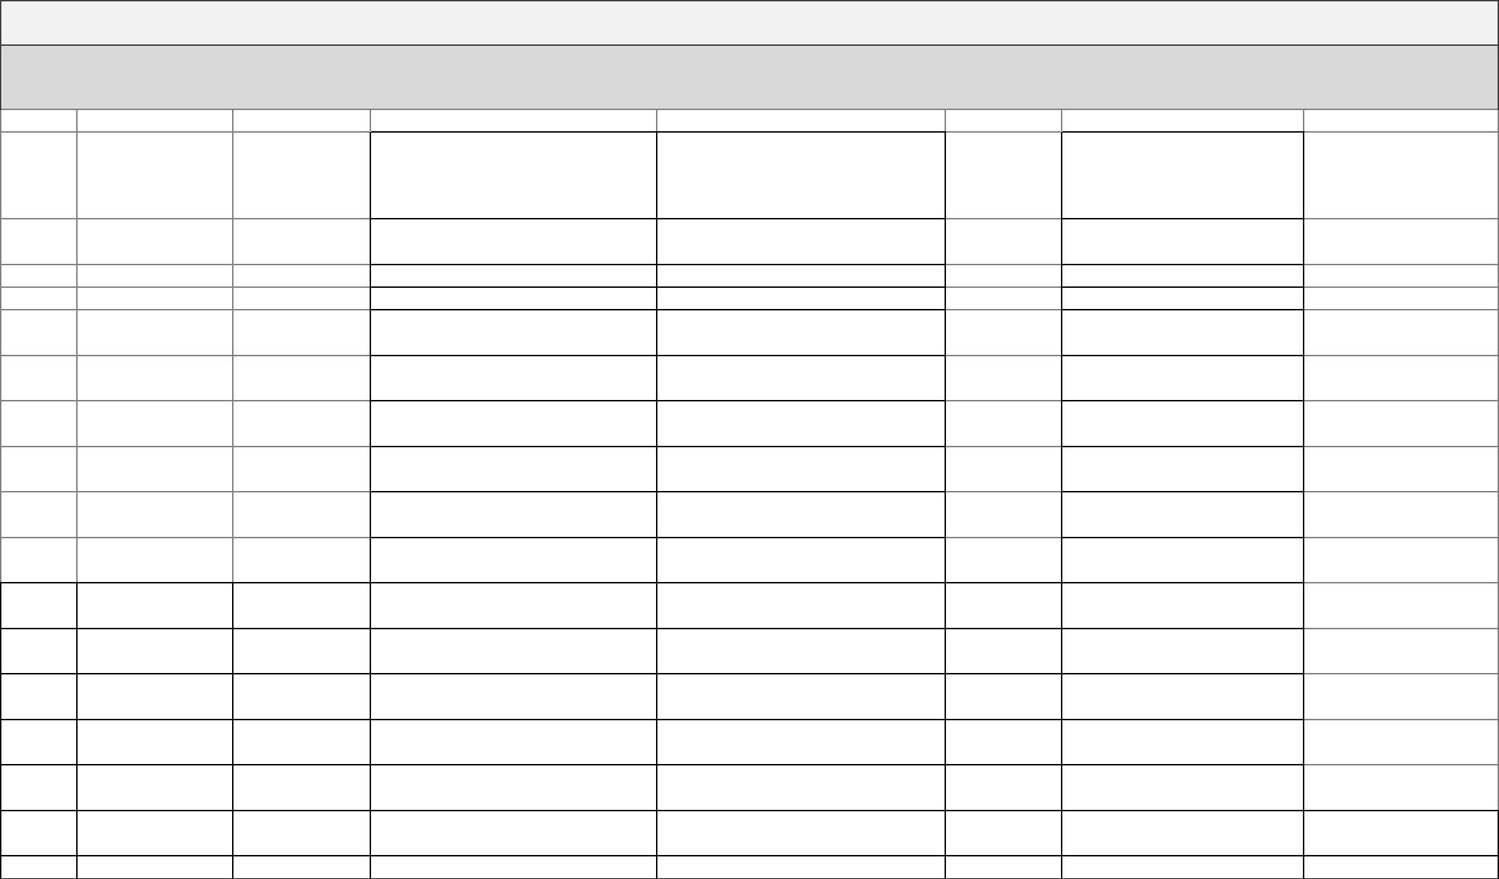

3/20/2020 Gaurab

3/25/2020 Gaurab

3/11/2020 Gaurab

3/12/2020 Gaurab

* 1. **Skill Audit 🡪Individual Skill Audit**

3/14/2020 Gaurab

3/15/2020 Gaurab

3/16/2020 Gaurab

3/17/2020 Gaurab

4/2/2020 Gaurab

3/7/2020 Gaurab

3/8/2020 Gaurab

3/9/2020 Gaurab

3/10/2020 Gaurab

3/18/2020 Gaurab

3/22/2020 Gaurab

* Team Skill Audit

**Skills Audit**

**Date Reviewed: 27/02/2020**

**Completed By: Team 5**

Traning Action

**Version**

**Skill Level: 1 (No Knowledge) - 5 (Competent)**

NO#

Skill Required

Skill Level ( 1- 5)

Training Objective

Time (hrs)

Training Completion Deadline

Traning for?

To become more confident using PHP

and in particular in the building

different shopping carts.

To have better knowledge regarding

database management system.

To revise the HTML tags and their

functions

Follow E-commerce web site PHP

3.1 tutorial on Youtube.

Extra guidence from youtube and

2.8 online courses.

1 PHP Programming

2 Database System

3 HTML

4

4

1

1

2

1

3/20/2020 Anamika,Aakriti,Bishwas,Mansi

Aakriti,

3/25/2020 Anamika,Mansi,Bishwas,Gaurab

4.2 Revise courses

4 Revise courses

3/11/2020

To revise the CSS attributes and their

use in website

4 CSS

3/12/2020

Website tutorial on youtube along with Able to understand real world

Aakriti,

5 Javascript

6 Photoshop

2.2 W3 school.

Learn from online photoshop video

3.3 tutorial website.

Javascript.

Able to create a layered photoshop

document.

3/14/2020 Anamika,Mansi,Bishwas,Gaurab

3/15/2020

3/16/2020

Become used to with the tools and for

Use of tools from YouTube tutorial and editing and creating photos or raster-

7 Illustrator

3.3 self practise.

based art.

1

Become more confident in the use of

Website tutorial from YouTube and W3 bootstrap framework to help us design

8 Bootstrap

9 MS Project

10 Documentation

11 Moqup

3.2 School.

Consulting with module leader and

2.1 taking online courses.

websites faster and easier.

Get better in keeping records of

activities.

2

3

1

2

1

1

1

3/17/2020

Aakriti,

4/2/2020 Anamika,Mansi,Bishwas,Gaurab

3.7 Practicing using strategic tips

Practicing complex wireframes of

4 websites

To become good in writing documents

Becoming more used to making good

wireframes

3/7/2020

3/8/2020

3/9/2020

3/10/2020

3/18/2020

Get better in writing all kinds of

12 Ms Word

13 Ms Excel

14 Qsee

4.2 Frequent use of Ms Word and its tools documents easily

Get better in keeping records and

3.9 Frequent use of Ms Excel and its tools calculation

Use of tutorials of software, creating

3.6 complex qsee diagram

Become comfortable in using qsee and

making qsee diagrams

To actively able to share and develop

knowledge about extracting data and

transfering it to database including

Online PayPal API documentation,

Aakriti,

15 API

16 XAMPP

1.4 refresher courses, youtube guidence. payment .

4.2

1

3/22/2020 Anamika,Mansi,Bishwas,Gaurab

3/25/2020

3.9 Online courses / YouTube tutorial

Learn about data Hadoop platform

To test the clients or your website

before uploading it to the remote web

server

Aakriti,

17 Apache

2 YouTube tutorial

2

3/27/2020 Anamika,Mansi,Bishwas,Gaurab

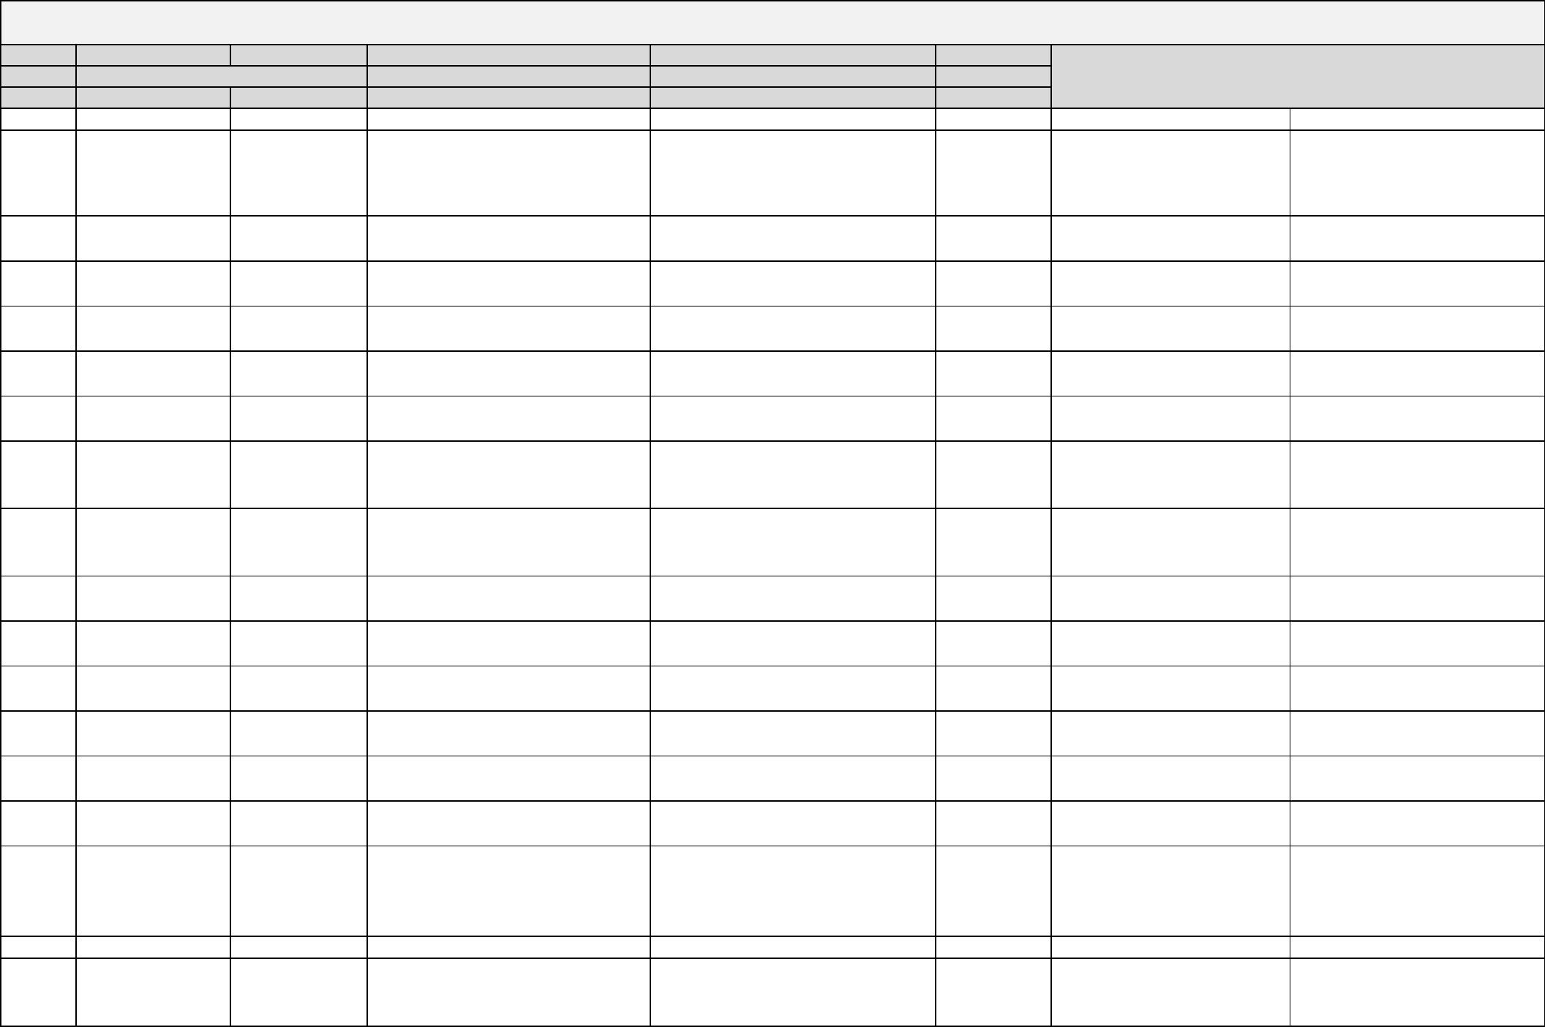

* + - * **Team Skill Audit**

2.3 Ms Project:-

* + - * Calendar

February 2020

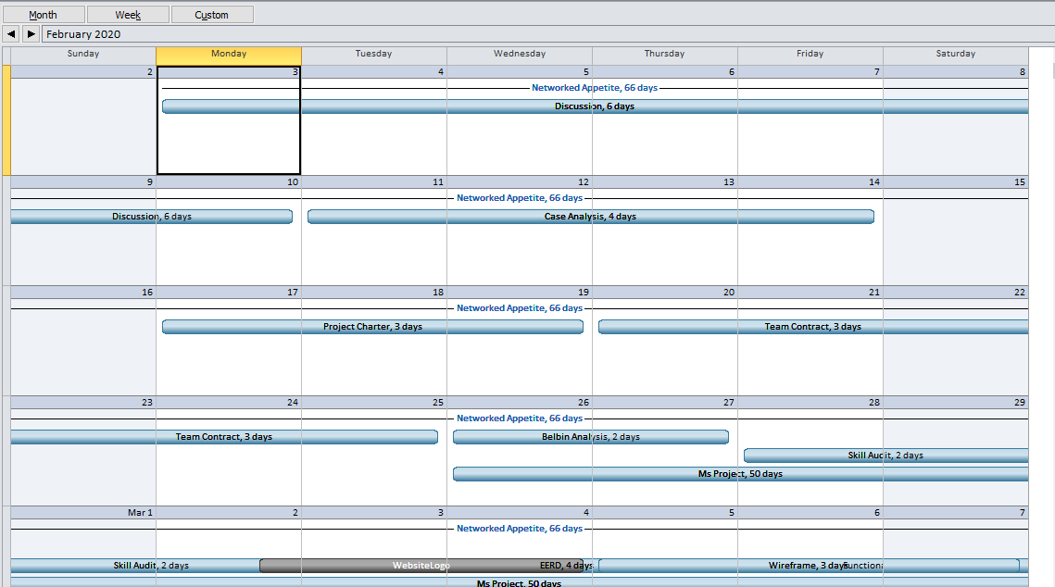

March 2020

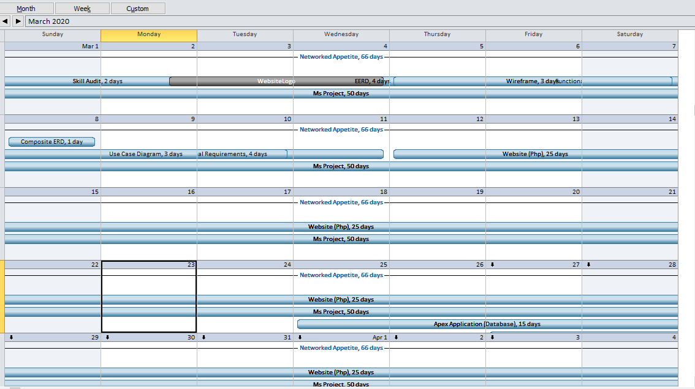

* + - * Network Diagram

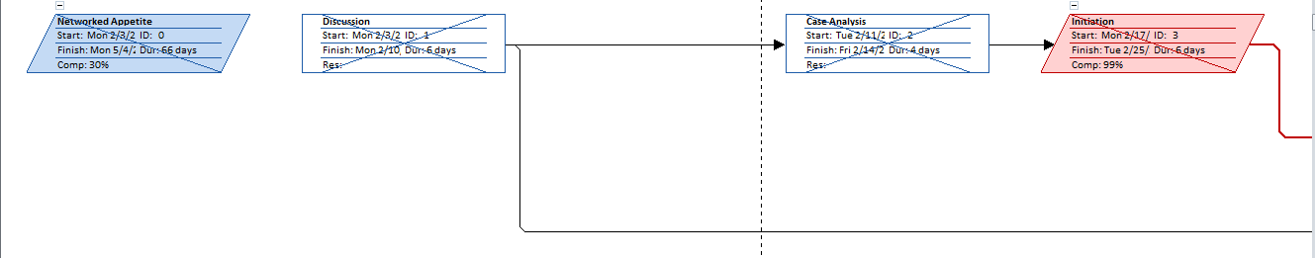

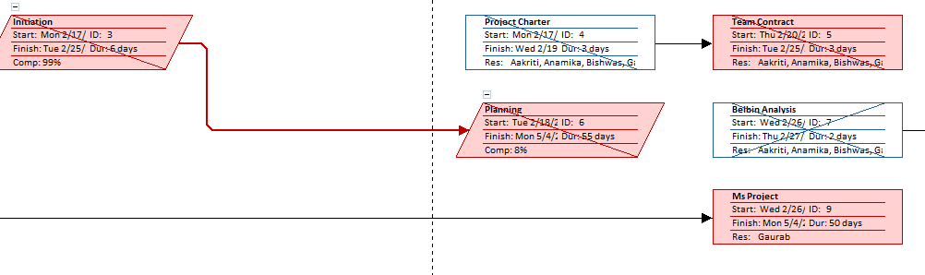

Note:- Belbin Analysis linked with Skill Audit

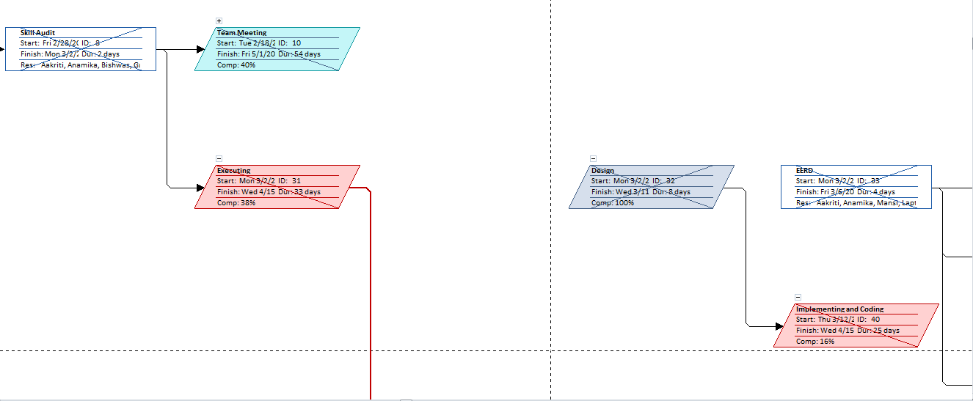

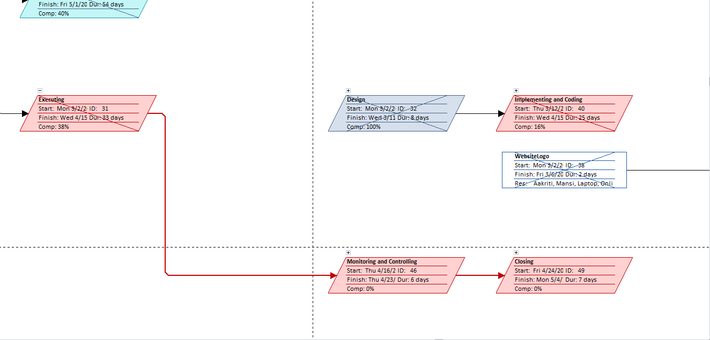

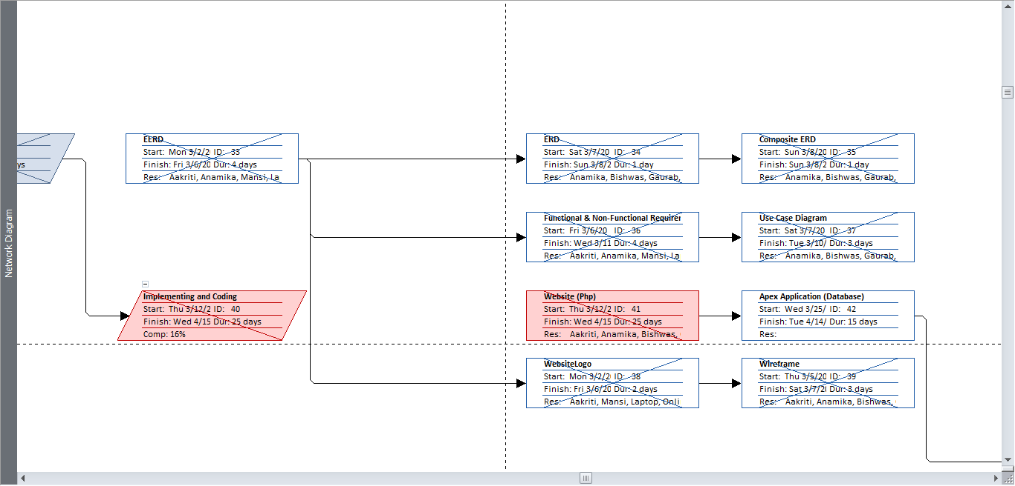

* + - * Timeline: 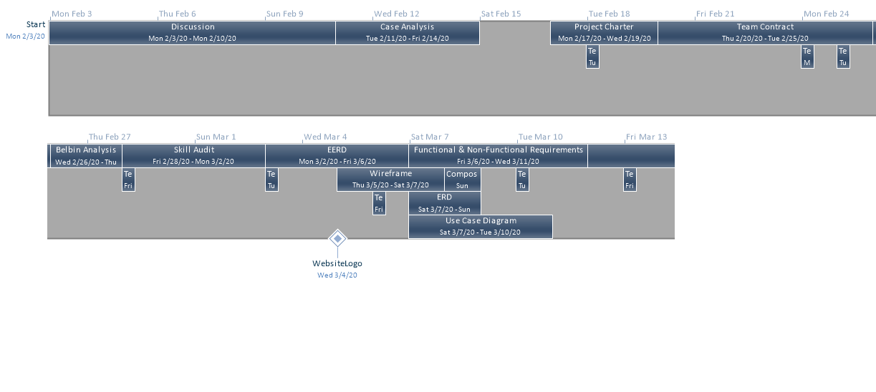
      * WBS

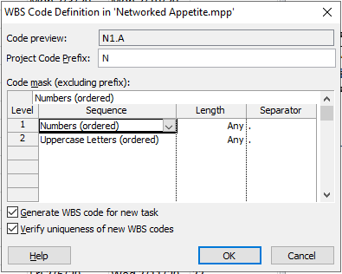

* Working Time

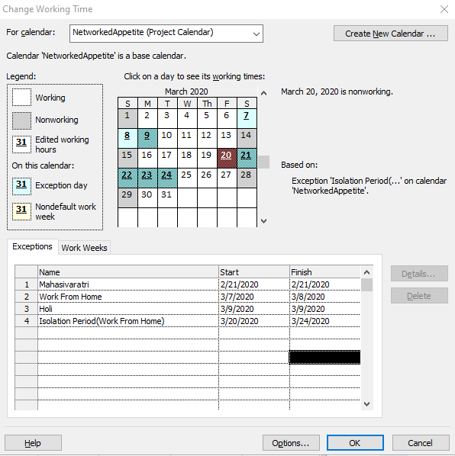

* Resource Sheet

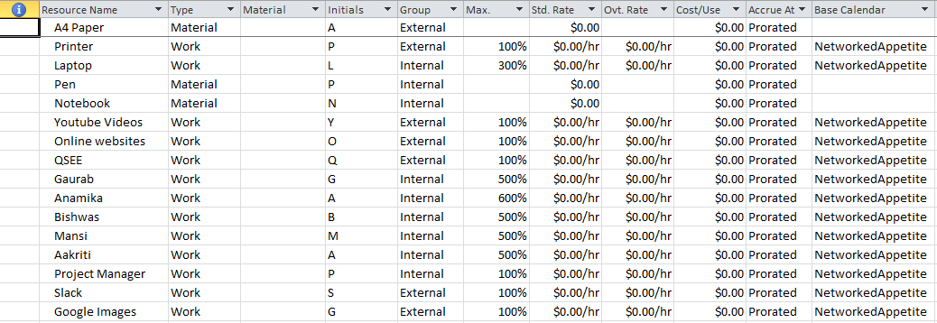

* Gantt chart

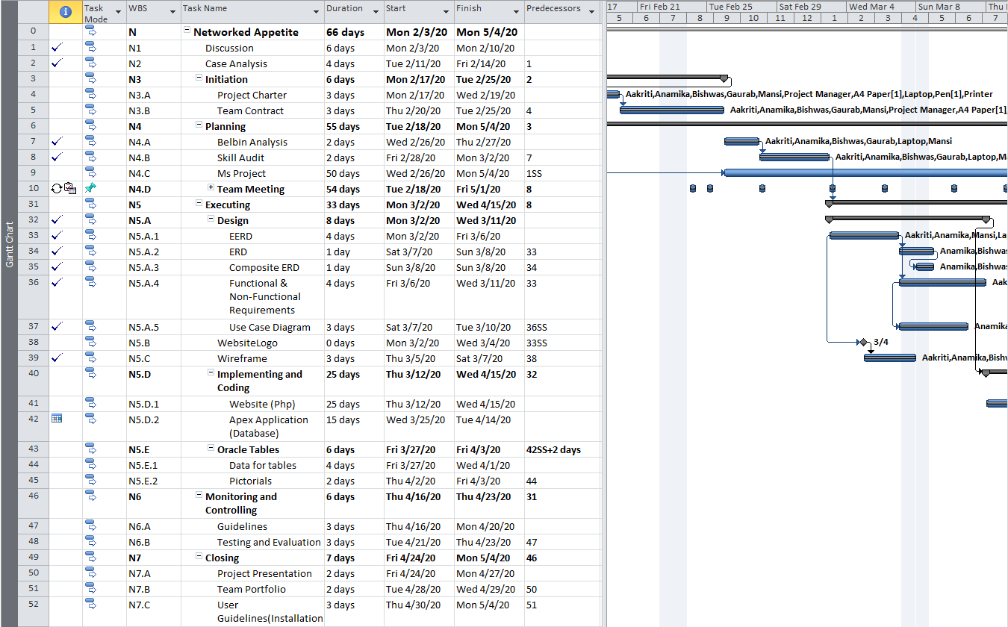

* 1. Communication Tools
* Slack

Slack used from February 23 as a means of communication between team members.

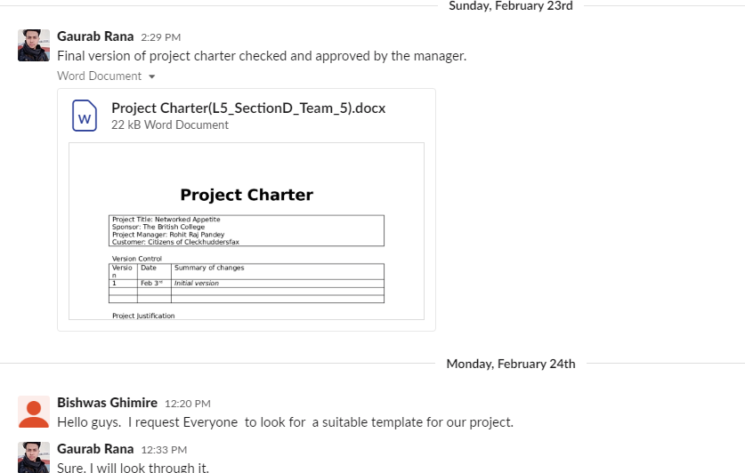

* Notifying team members and checking work completion. Group call whenever necessary.

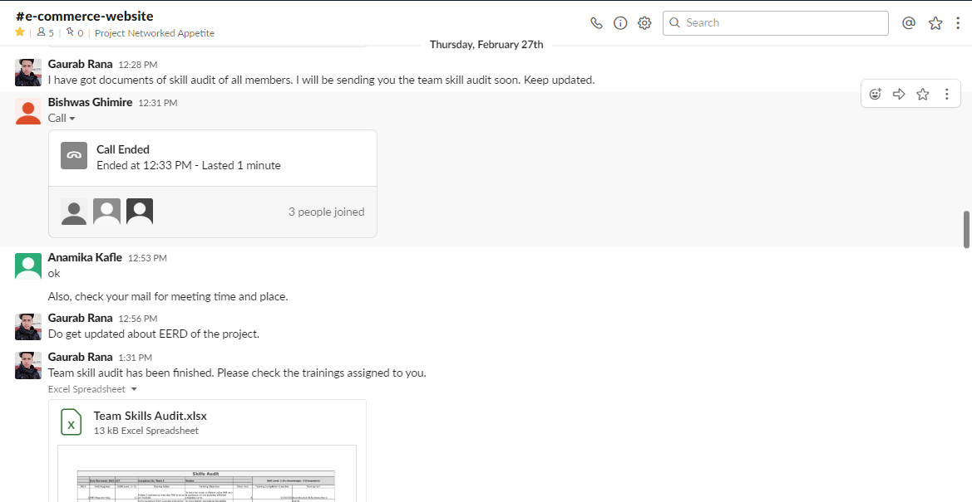

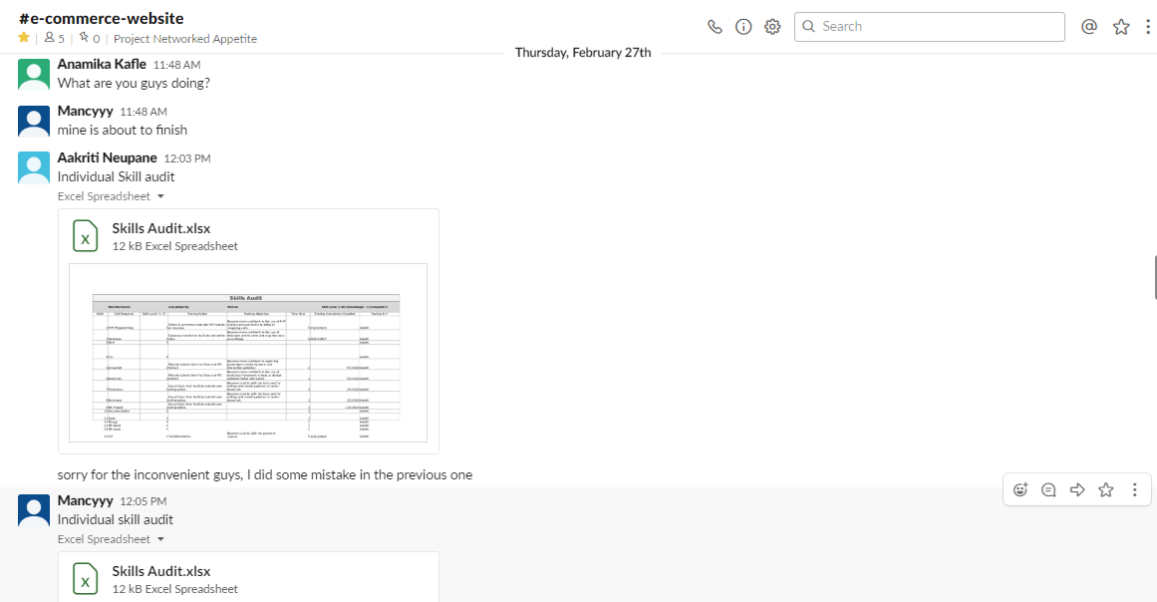

* File Sharing

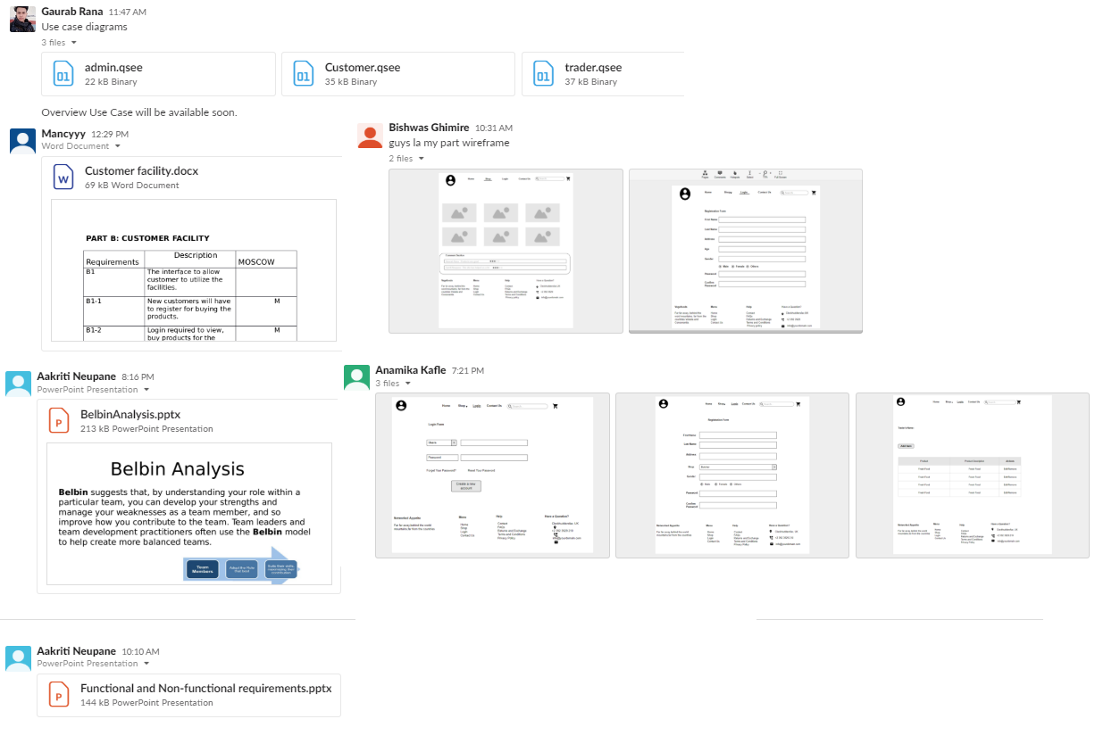

**3. Execution**

3.1. Entity Relationship Diagram

* EERD

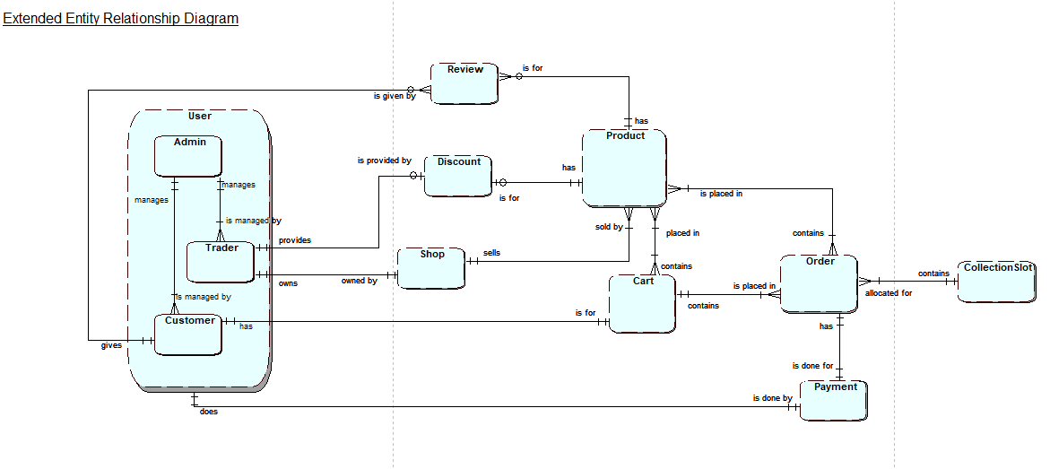

* ERD



* Final Composite

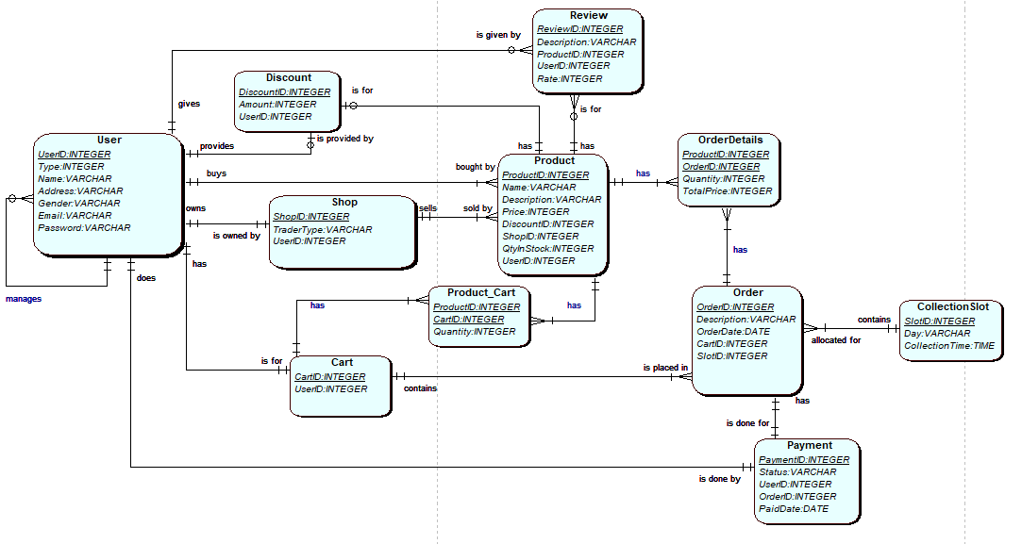

* Logical Table

|  |  |
| --- | --- |
| Entity Names | Attributes |
| 1. User | UserID, Type, Name, Address, Gender, Email, Password |
| 1. Shop | ShopID, TraderType, *UserID* |
| 1. Cart | CartID, *UserID* |
| 1. Discount | DiscountID, Amount, *UserID* |
| 1. Review | ReviewID, Description, *ProductID, UserID,* Rate |
| 1. Product | ProductID, Name, Description, Price, *DiscountID, ShopID,* QtyInStock, *UserID* |
| 1. Product_Cart | *ProductID*, *CartID*, Quantity |
| 1. Order | OrderID, Description, OrderDate, *CartID*, *SlotID* |
| 1. OrderDetails | *ProductID,OrderID,* Quantity, TotalPrice |
| 1. CollectionSlot | SlotID, Day, CollectionTime |
| 1. Payment | PaymentID, Status, *UserID, OrderID* |

3.2. Use Case Diagram

Overview Use Case Diagram

* Customer Use Case Diagram



* Trader Use Case Diagram



* Admin Use Case Diagram



3.3. Requirement Catalogue

* Functional Requirement

**Part A: PRODUCTS**

|  |  |  |
| --- | --- | --- |
| Requirements | Description | MoSCoW |
| **A1** | **The interface to allow customer to view and buy products** |  |
| A1-1 | Items will be displayed with at least title, short description and a suitable thumbnail image. | M |
| A1-2 | Users will be able to display items by category | M |
| A1-3 | Users will be able to be use open text search for items | S |
| A1-4 | Users will be able to sort/search items based on multiple search criteria. | C |
| A1-5 | Products will be applied with discounts. | S |
| **A2** | **The interface allow user to add products to cart** |  |
| A2-1 | User can add items to cart with or without logging in. | M |
| A2-2 | Users should be able to remove individual item or all items from cart. | C |
| **A3** | **The interface allows customer to give reviews about product** |  |
| A3-1 | Customer can view reviews and give reviews about product | M |
| A3-2 | Customer can give reply to other customer’s reviews. | W |
| **A4** | **The interface allows customers to specify collection slots** |  |
| A4-1 | Customer can select specific collection slots time after payment | M |
| A4-2 | Customer can select collection slot available only after 24 hours of order placed. | M |
| A4-3 | Orders are limited to 20 per collection slot. | M |
| **A5** | **The interface allows customer to use online payment system.** |  |
| A5-1 | Payment for product is done using PayPal. | M |
| A5-2 | Payment invoice goes to customer, admin and respective traders. | S |

**Part B: CUSTOMER FACILITY**

|  |  |  |
| --- | --- | --- |
| Requirements | Description | MoSCoW |
| **B1** | **The interface to allow customer to utilize the facilities.** |  |
| B1-1 | Customers will be able to add products to cart for further processing. | M |
| B1-2 | Customers have access to search products. | M |
| B1-3 | Customers can edit item quantity to buy products. | S |
| B1-4 | PayPal is the only option for customers buying the products. | M |
| B1-5 | Customers can also view best deals for coming new products. | M |
| **B2** | **The interface allow customer to register as a verified user.** |  |
| B2-1 | Customers will have to register for buying the products. | M |
| B2-2 | Customer will have to complete a form to register. | M |
| B2-3 | Register form fields will have password length check and encryption, and collect username, address, email, age, and password. | C |
| B2-4 | Email Verification is required to verify user. | S |
| B2-5 | Customers are able to manage and update accounts. | S |
| **B3** | **The interface to allow customers to login** |  |
| B3-1 | Email address and password required to login. | M |
| B3-2 | Login required for buying products. | M |
| B3-3 | Customer can reset password using email verification. | S |

**Part C: TRADER FACILITY**

|  |  |  |
| --- | --- | --- |
| Requirements | Description | MoSCoW |
| **C1** | **The interface to allow traders to manage the products.** |  |
| C1-1 | Traders will be able to manage products and its related information. | S |
| C1-2 | Traders will be able to run daily, weekly and monthly report ordered in a number of ways: alphabetically, by total number of orders per product, by total income per product. | S |
| C1-3 | Traders will be able to login their respective ID and view their details. | S |
| C1-4 | Traders will be able to view and update the details of their respective accounts. | S |
| C1-5 | Traders will be sent email verification link in order to proceed to the site. | C |
| C1-6 | Traders will be able to provide discount to the customers. | C |

**Part D: ADMIN FACILITY**

|  |  |  |
| --- | --- | --- |
| Requirement | Description | MoSCoW |
| **D1** | **A facility to allow authenticated admin users to manage the activities presented by the system.** |  |
| D1-1 | An active admin link will be provided once an admin user has logged in. | S |
| D1-2 | The admin page will display all activities and can access any trader account. | S |
| D1-3 | Clicking the update link will show a form pre-populated with all editable details. Submitting the form will update the chosen item and display the updated item. | S |
| D1-4 | Clicking the delete link will remove the chosen item and update the displayed catalogue of items. | S |
| **D2** | **A facility to allow admin to track activity of products and traders.** |  |
| D2-1 | Admin will keep the uniqueness of each product of traders in check. | M |
| D2-2 | A dashboard will be shown with overview of reports, sales, activities of customer and traders. | S |
| D2-3 | Admin will facilitate traders with daily report on goods and stocks, weekly report on finance and monthly report on their product sales. | M |

**Part E: Web Interface**

|  |  |  |
| --- | --- | --- |
| Requirements | Description | MoSCoW |
| **E1** | **Web interface for website design** |  |
| E1-1 | The site will be viewable on mobile as well as desktop devices and viewable on the most popular browsers. | M |
| E1-2 | The site will have good reflection of heritages of the area | C |
| E1-3 | The system will support a maximum of 10 shops in the first instance. | S |
| E1-4 | Traders will be able to manage products and do CRUD operations via web interface. | M |

* **NON-FUNCTIONAL REQUIREMENTS**

The website will comply with the following non-functional requirements.

|  |  |  |
| --- | --- | --- |
| Requirements | Description | MoSCoW |
| F1-1 | HTML /CSS template suited to requirements. | M |
| F2-2 | Template applied consistently throughout the site. | S |
| F3-3 | Site built for maintainability: Files organized, comments added, HTML using includes bespoke functions. | S |
| F4-4 | Backing up the data. | C |
| F5-5 | Information security. | C |
| F6-6 | The website shall be secure from hackers. | M |

3.4. Logo Design



**3.5. Wire Frames**

* Homepage

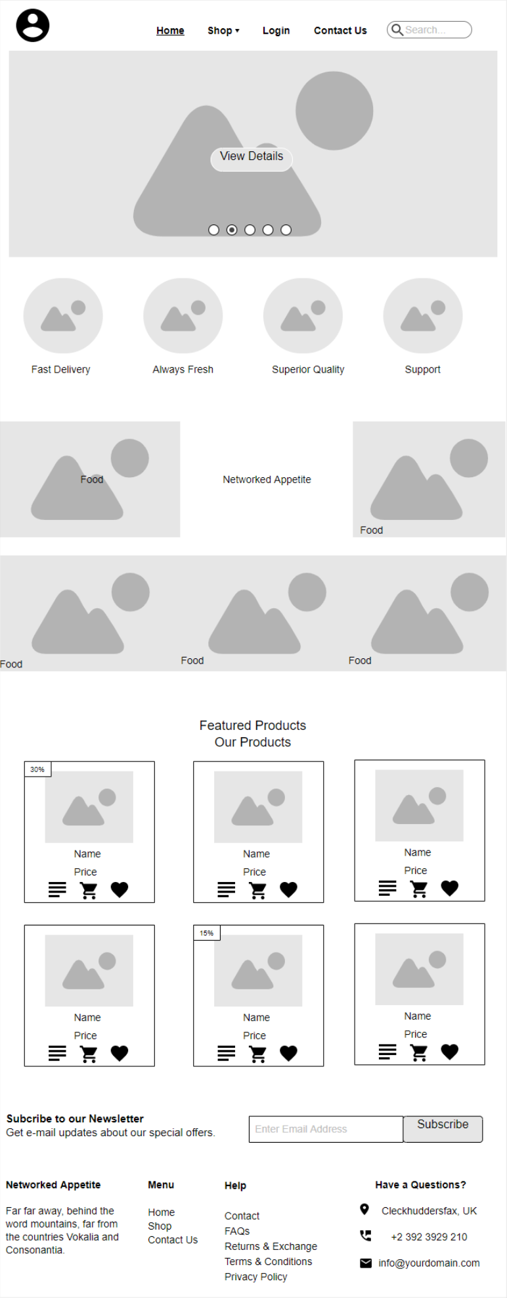

* Shop

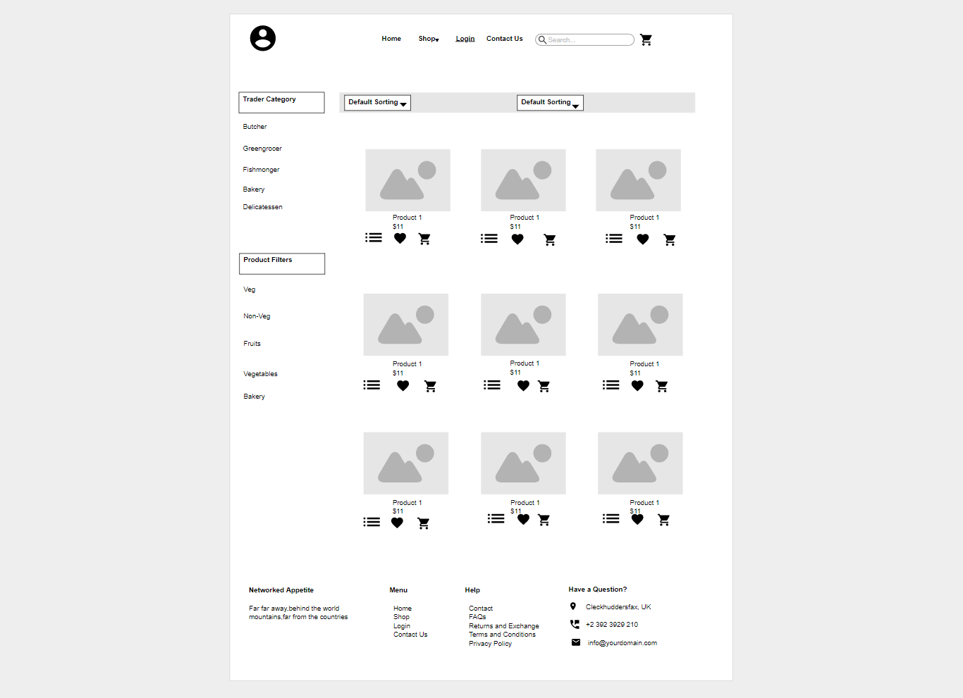

* Contact Us

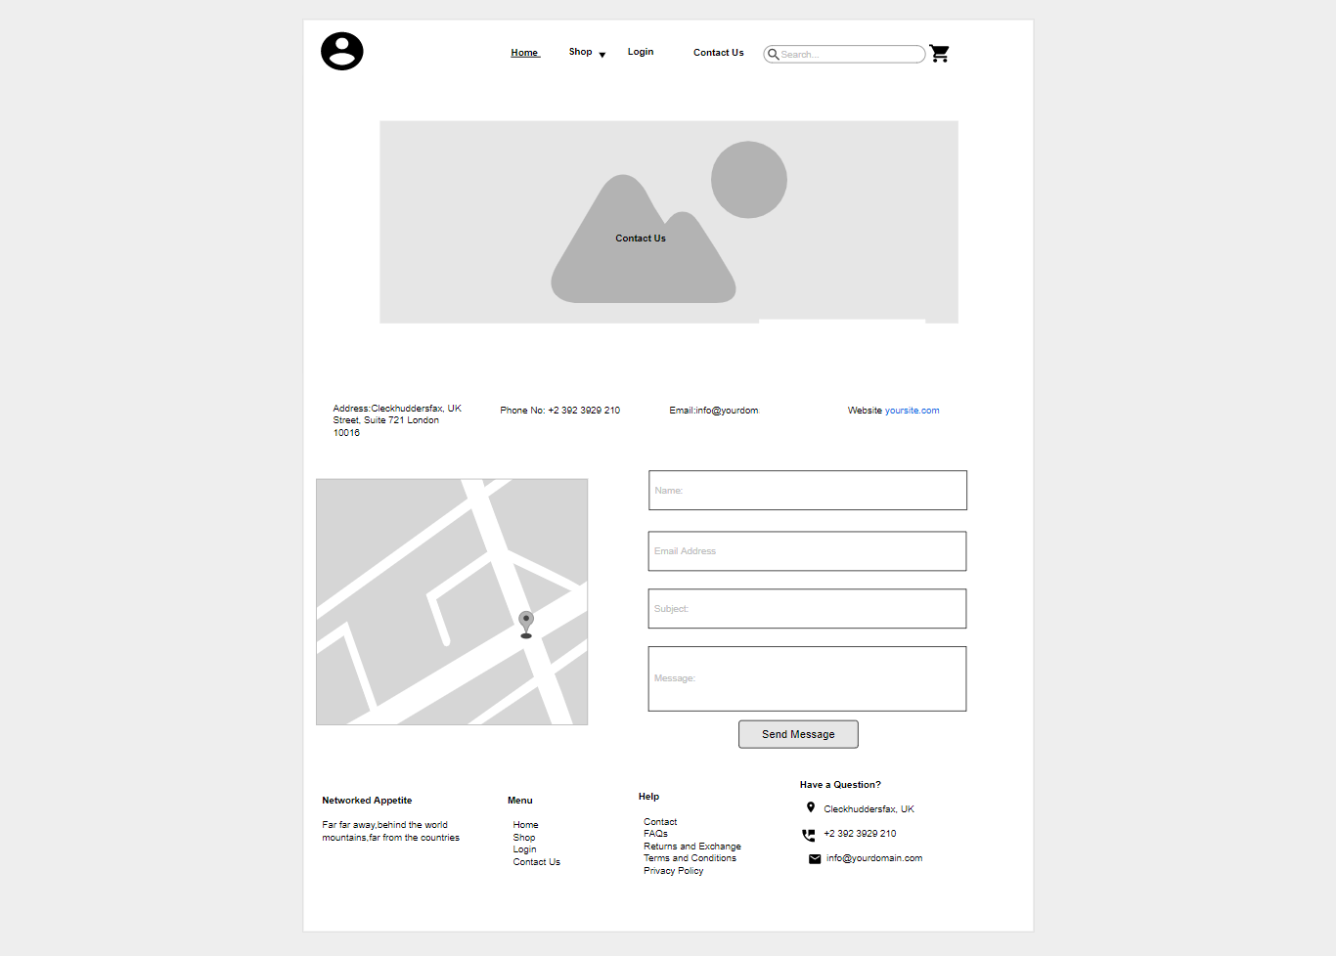

* Login

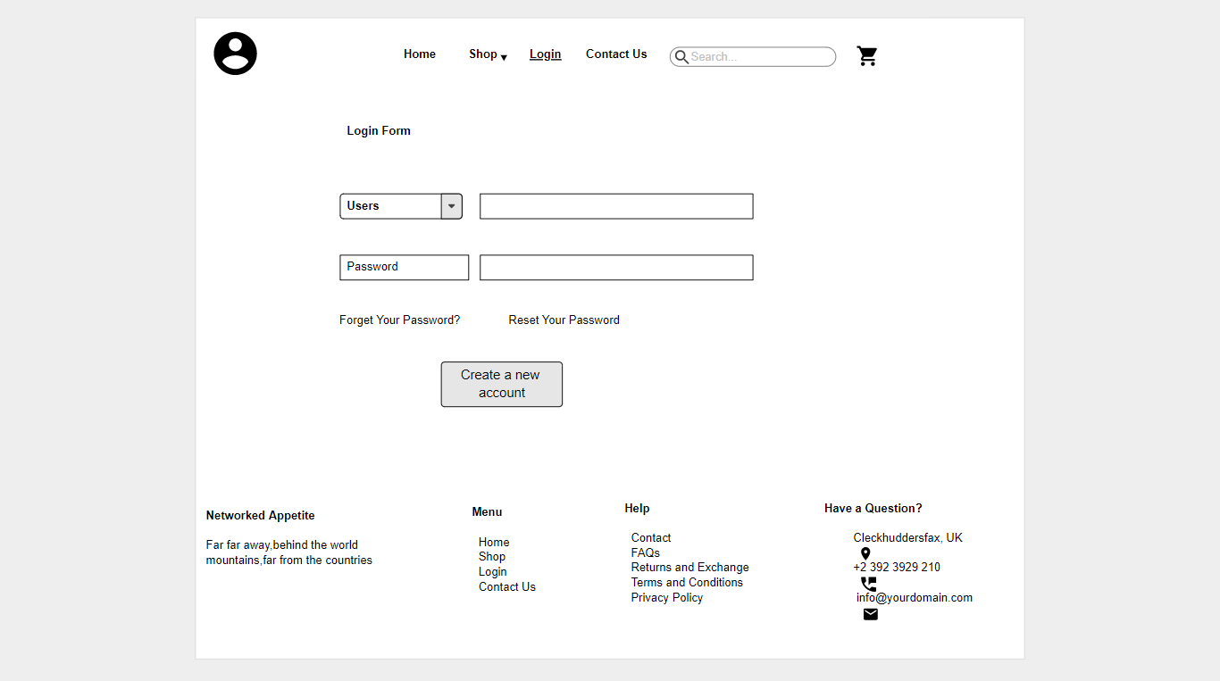

* Register(Customer)

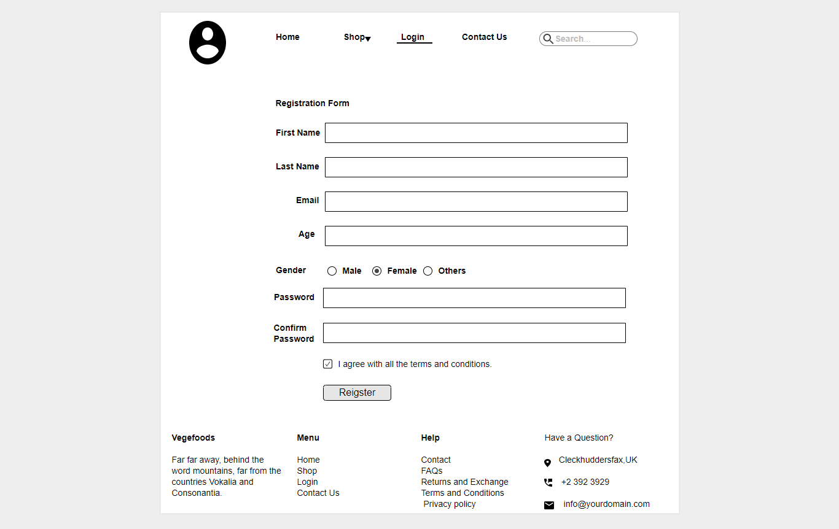

* Register(Trader)

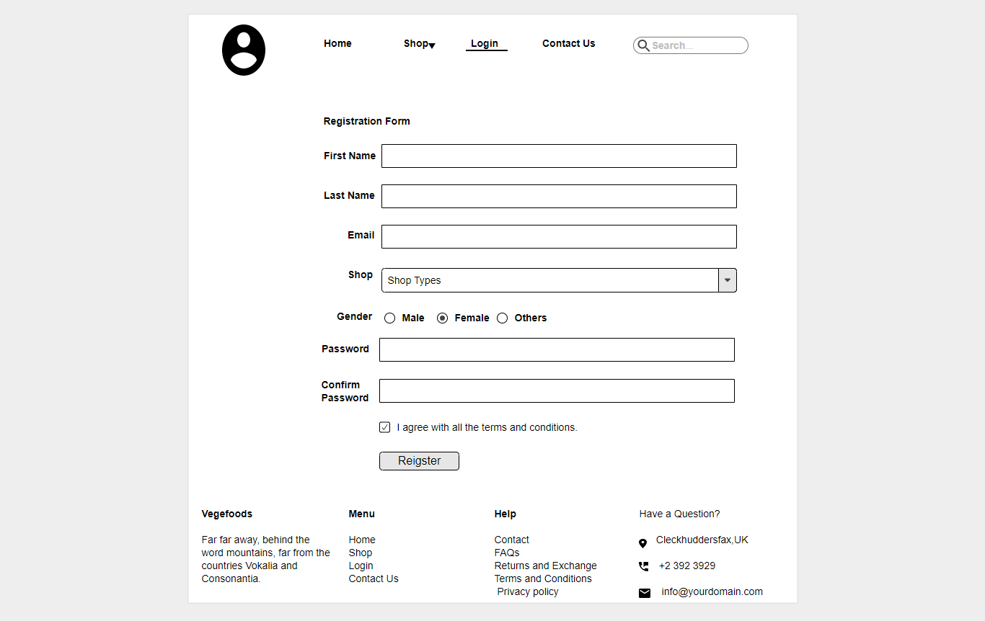

* My Cart

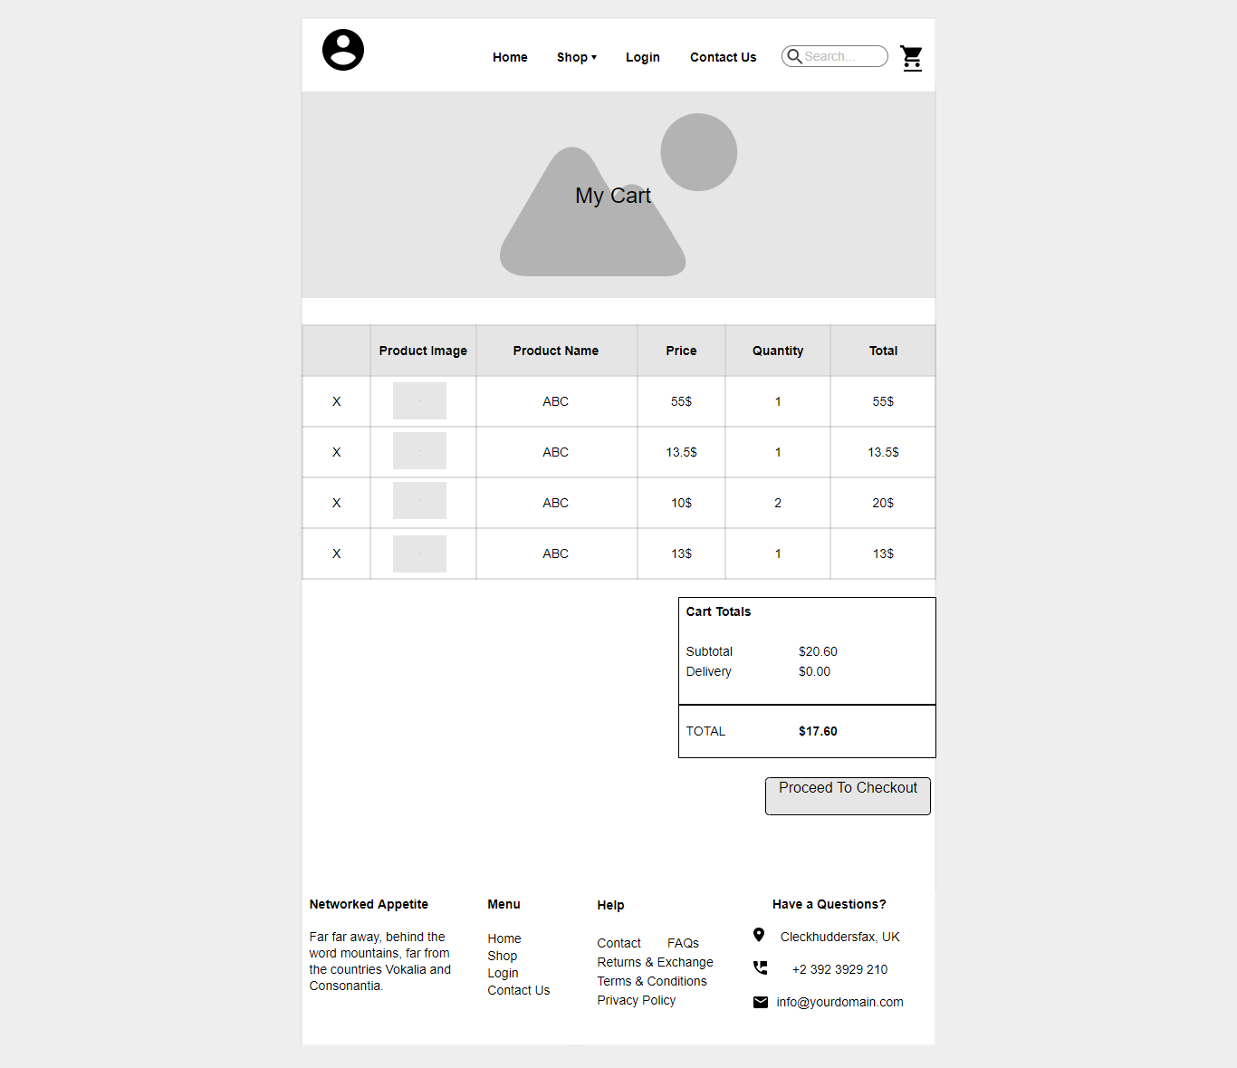

* Customer Comment

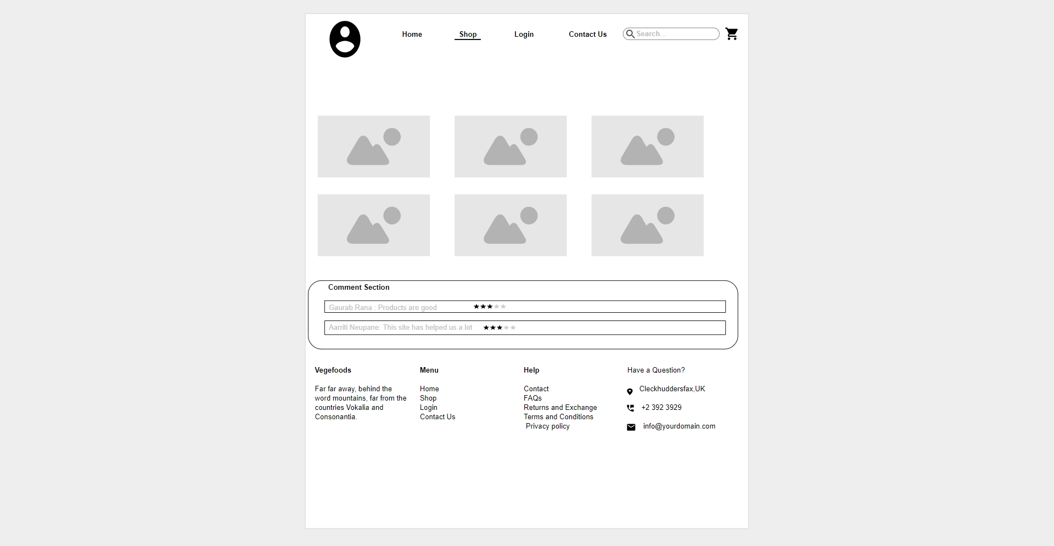

* Trader CRUD functions

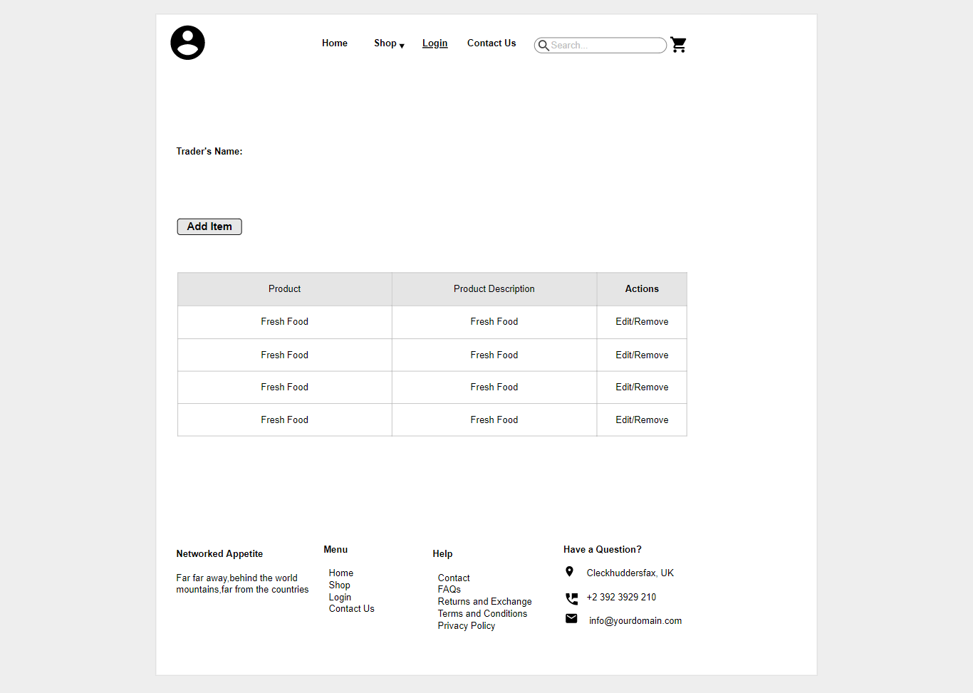

* Invoice

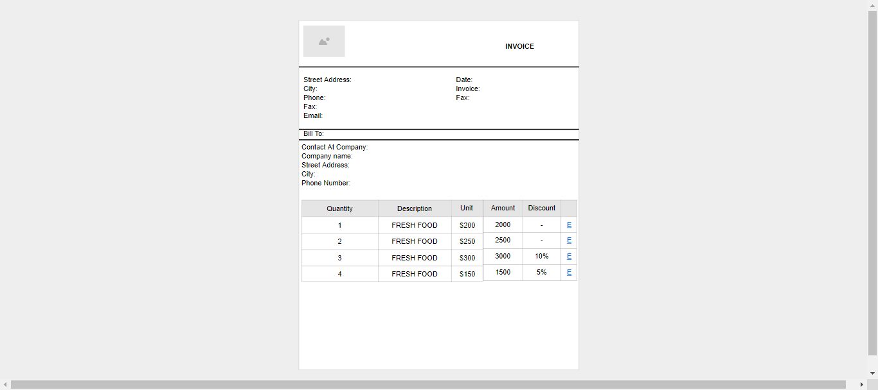

* 1. Product Development

Homepage code

